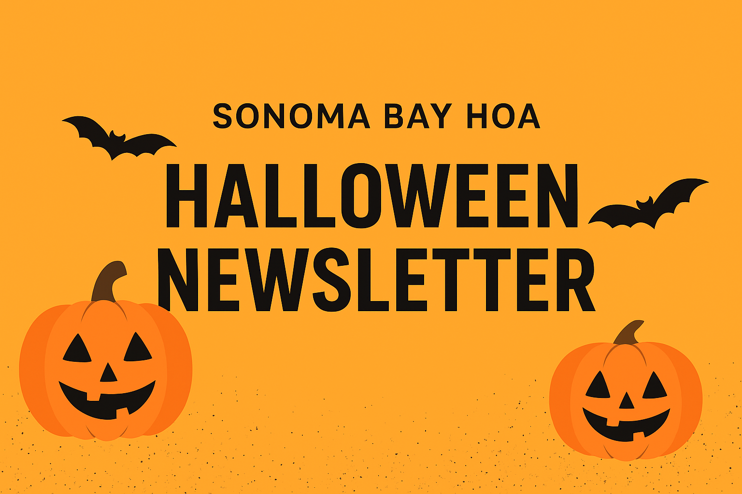

October 2025 Edition

👻 Trunk or Treat & Movie Night 🎬
Get ready for a spooky fun night! Join us this **Friday, October 31st, 2025** for our annual Trunk or Treat event followed by a family-friendly movie under the stars. The Trunk or Treat begins at **6:30 PM** and the movie will start promptly at **8:00 PM** in the tennis court area. Don’t forget to bring your blankets and chairs!

🦇 Halloween Safety Tips
- • Always use reflective gear or glow sticks when trick-or-treating.
- • Stay in well-lit areas and walk on sidewalks whenever possible.
- • Check all treats before eating.
- • Drive slowly through the community and watch for children crossing streets.

🗑️ Community Trash Reminders
Please remember to throw all household trash **inside** the dumpsters and not leave bags sitting outside. If your nearest dumpster is full, kindly take your trash to the next available one. Bulk trash must be placed in the designated bulk trash areas located at the end of Sonoma and Hibiscus. If those areas are full, please hold your items until they are emptied on **Wednesdays**.

🌿 Back Patio Guidelines
Please note that back patios should only contain outdoor furniture, potted plants, and a grill. Any other items are considered violations and may result in a notice from the HOA.

🧱 Paver Painting & Repairs
We appreciate everyone’s cooperation with the paver painting and repair project. Please note that homeowners who have not yet complied will receive individual violation notices before the matter is brought to the HOA Board for further review.

Thank you for helping keep Sonoma Bay beautiful and safe!
We look forward to celebrating Halloween with all of you this Friday night! 🎃👻

