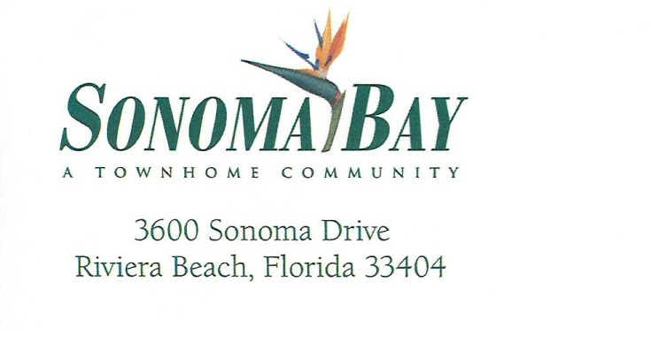

**Dear Sonoma Bay Homeowners,**

We hope this message finds you well.

Recently, the HOA has received an increased number of emails and concerns regarding the use of mopeds, electric scooters, and other similar vehicles within our community. Specifically, many residents have expressed concerns about unsafe riding habits and a lack of awareness regarding oncoming or passing traffic.

In response, the HOA Board has made a motion to implement updated guidelines to address these safety concerns. These new guidelines include, but are not limited to, the following:

1. **No ball playing is permitted on the streets of Sonoma Bay.**  
   This rule is in place to protect the safety of our residents and to prevent any potential damage to private property. Any resident that would like to play ball can use the tennis courts, the HOA will remove the tennis court nets to allow the space to play.
2. **Use of the Tennis Court:**  
   Residents who wish to use the tennis court must contact the Property Manager via email with the requested date and time of play. The maintenance team will ensure the net is set up accordingly.
3. **Electric Bikes, Scooters, And Mopeds:**  
   Residents riding e-bikes, mopeds, or electric scooters must do so with caution and remain vigilant of all traffic. Florida law states that you MUST be 16 years or older with a class E or motorcycle license to operate a moped.
4. **Pedestrian and Rider Responsibility:**  
   All residents must be mindful of moving vehicles and should promptly move to the side of the road to allow traffic to pass safely.

These guidelines are designed with everyone's safety in mind and to maintain the harmony and quality of life we all value here in Sonoma Bay.

We appreciate your cooperation and understanding as we work together to ensure a safe and respectful environment for all.

Sincerely,  
**The Sonoma Bay HOA Board**